**DEPOSITOR PAGES : (USE CASES and FUNCTIONS)**

1. **INVENTORY (Archived By SK)**

The Depositor or the user created under a Depositor (a.k.a Depositor user) will see this below page of inventory in his web panel, it will show the list of all the containers which are archived by SK admin in there warehouses. Below are the use-cases or functions depositor or depositor user will perform.

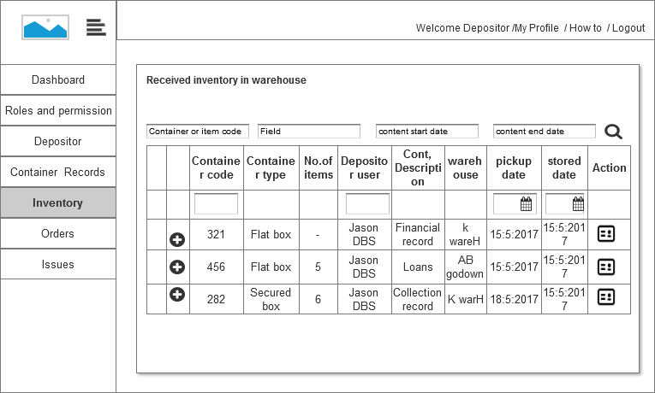

**Screen 1 : Container list page of INVENTORY**

* Depositor will see the list of all the containers stored in different warehouse (latest one on top).These container cannot be edited as they are archived in warehouse.
* Depositor can view the list of item each container holds, using  icon, the item list will drop down below.
* Depositor can view the container details using  icon , he will be directed to the container detail page . See screen 2.
* Depositor can do filtering of the container and its details, using
* “Container code or item code” ( with item code , the container will be visible which consists that item)
* “Field”, will show the containers which have items having that field name fully or partially.
* “Content start and To date”, will show containers which has the content date in the container content date range.

These filters will show cumulative results, used in any order.

* Depositor can also narrow down the result with table embedded filters; this will be consecutive to above filter. These filter are:
* Container code (may not be required)
* Depositor name
* pickup date ( The date when pickup has been requested by the depositor )
* Stored date (the date when the container has been stored in warehouse)
* The list page , column details are :
* Container code
* Container type
* Number of items the archived container consist of
* Depositor user name.
* Container description
* Warehouse name
* Pickup date
* Stored date , stored in warehouse

This will accompany action to view the container details, also easy expand and collapse icon , to view the item details will be present in the page.

**Container details (in the achieved inventory)**

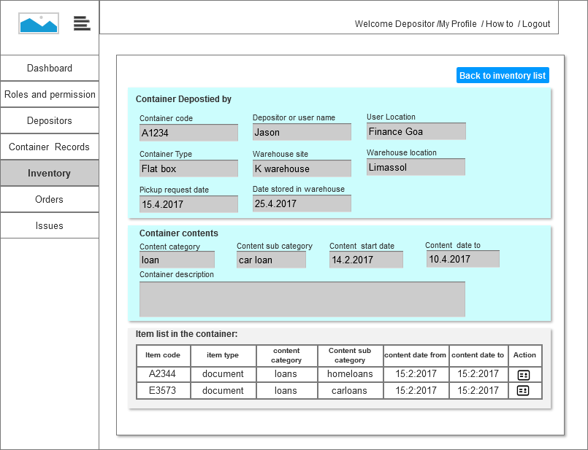

**Screen 2 : Container detail page of INVENTORY**

Upon clicking the container details using  , Depositor sees this page . This page is not editable only can be viewed. The various details it shows are:

* Depositor user details with container details
* Container code
* Depositor user name
* Depositor user location
* Container type
* Warehouse name,
* Warehouse location
* Pick up request made
* Container store date
* Content details
* Content category
* Content sub category
* Content start date
* Content to date
* Content description
* Item list, which the container consists to view the item details, the depositor can view item details by  icon in the item row. (Item detail page , screen 3 )
* The item row describes:
* Item code
* Item type
* Content category
* Content sub category
* Content date from
* Content date to
* It will also show simple icon to get back to inventory page.

**Item details (in archived container)**

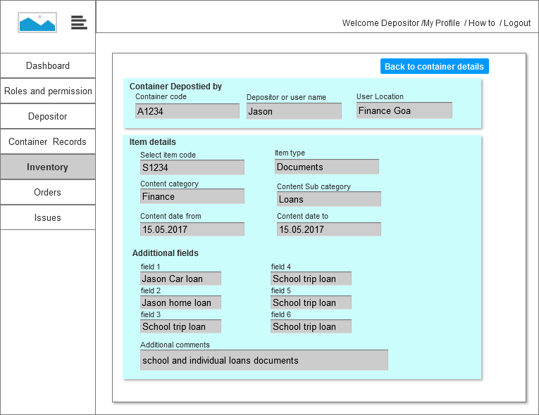

**Screen 3: item detail page of INVENTORY**

The item detail page will show item details; these details will not be editable:

* Container deposited by , the elements it has:
* Container code
* Depositor user name
* Depositor user location.
* Item details. the element it has:
* Select item code
* Item type
* Content category
* Content sub category
* Content start date
* Content TO date
* Fields or tags used for the item
* Additional comment to the items.

1. **CONTAINER RECORDS (Containers with Depositors**)

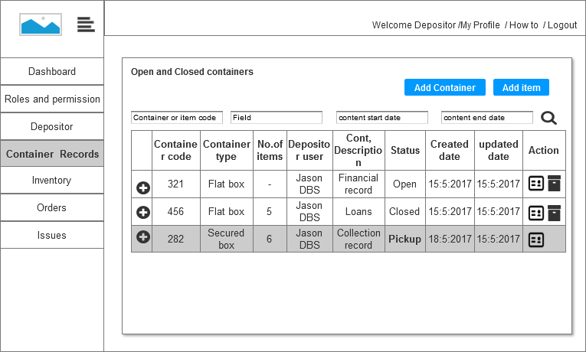

**Screen 4: Container records (Containers which is with the depositors, i.e before pickup)**

Before the container is requested for pickup, the depositor user is required to fill the container with items. For the same he will require adding a container and then to the container added he will require adding items into it. Till the container is not closed the container details cannot be updated with new items or taking out already present item. When the pickup request has been placed, the item cannot be deleted from the container record. Following use cases or functions in this page can be observed:

* List of Containers which are added, with item list which are present in a container row.
* The container detail page can be seen with this icon  . Till the container is closed
* The container which is CLOSED or OPEN can be deleted, Once the container is in PICKUP state, the container cannot be deleted from the container records.
* The row will show status PICKUP , pickup request has been done, and will not move to inventory list if confirmation from the warehouse is not received by the system. (Thus Pick up status will stay even in the IMPORT state in pickup request orders)

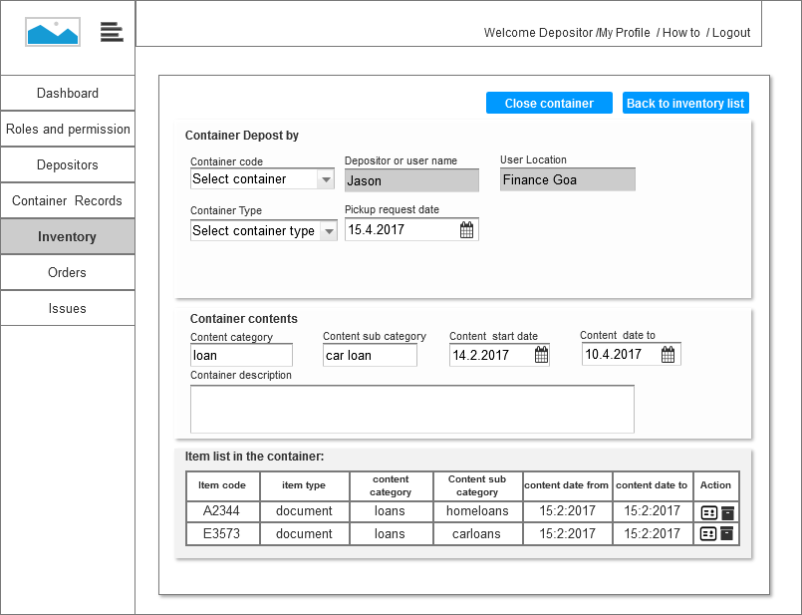

**Screen 5: Close container from OPEN status**

* OPEN container can be edited with the details, the above screen shows the details and no warehouse details as it has not been set by the SK admin.
* The items in the open container can be deleted.
* To add the item details or view the item details  icon should be used to view the item form or detail page.
* The item in the open container can be deleted using  delete icon. The item list consists of
* Item code
* Item type
* Content category
* Content sub category
* Content date from
* Content date to
* The container can be closed with the “CLOSE CONTAINER” button.

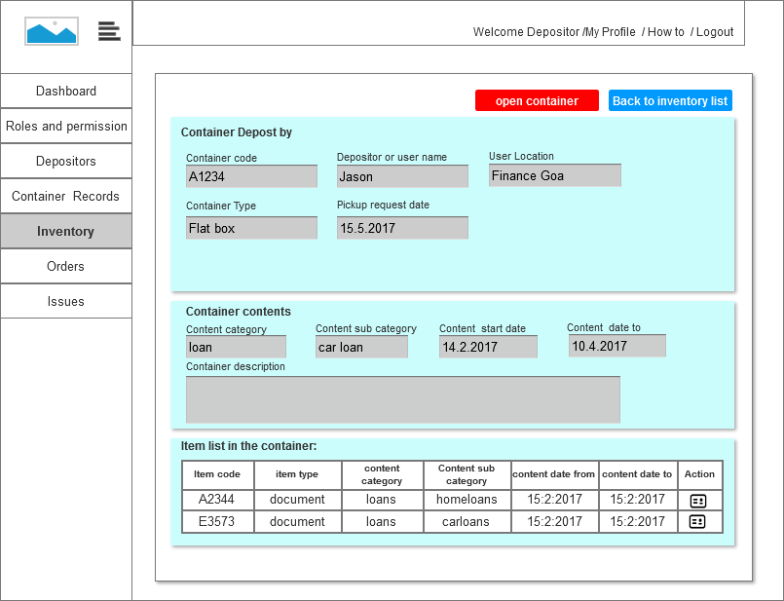

**Screen 6: Open container from Closed status**

* Once container is closed, the container details or item details cannot be edited or update or deleted.
* The details can only be viewed.
* The closed container can be Opened again using the OPEN CONTAINER,
* When the container is in PICKUP , it cannot be made OPEN again

**Expand container details**

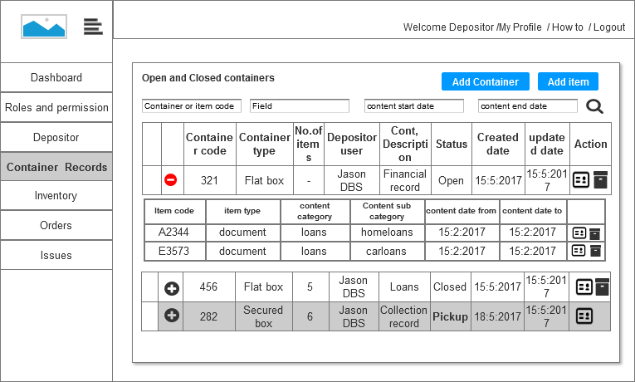

**Screen 7 : collapse or expand**

*  this expands the container row with items it posses
*  this collapse the container row .

**Add container**

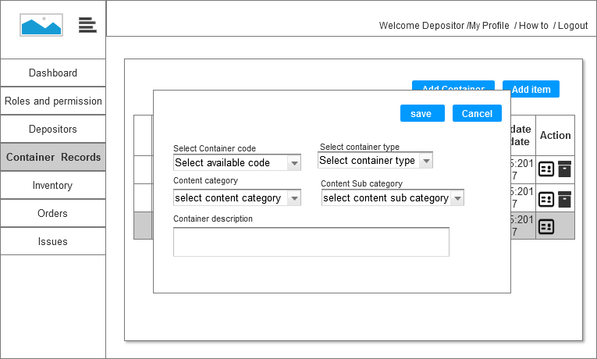

**Screen 8: Add a container (container record page)**

* Using ADD CONTAINER button, depositor user can start adding a container which he requires later to be sent to warehouse.
* It consists of simple pop up form ,the form details are:
* Select container code available for assigning (a table of available barcodes will be maintained)
* Container type.
* Content category
* Content sub category
* Container description
* After successfully adding the container, it will get listed in the container record list page (screen 4)

**Add item in OPEN container**

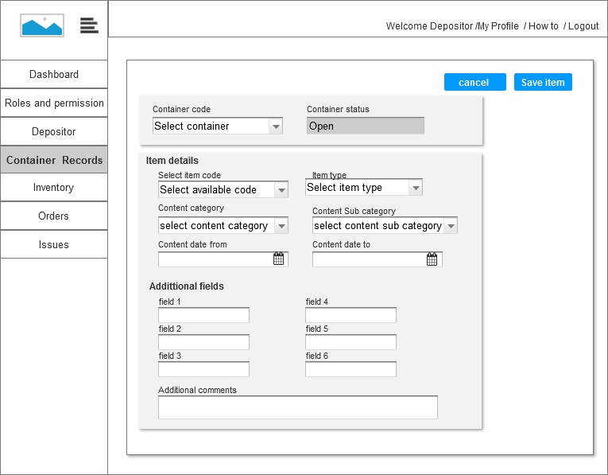

**Screen 9: add item details to a container, (same page for update the item details)**

The item detail page will show item details; these details will be editable

* Container deposited by , the elements it has:
* Container code (codes from available Barcode)
* Status (Open) (not editable)
* Item details. the element it has:
* Select item code
* Item type
* Content category
* Content sub category
* Content start date
* Content TO date
* Fields or tags used for the item
* Additional comment to the items.

1. **DEPOSITOR**

The section and pages to the depositor is very similar to below link, It will be updated with the fields if required.

<http://demo-host.co/mumbaiall/harshal/sk/depositors-defination.php>

1. **ORDER**
   1. **ORDER PICKUP**

**Pick up request date**

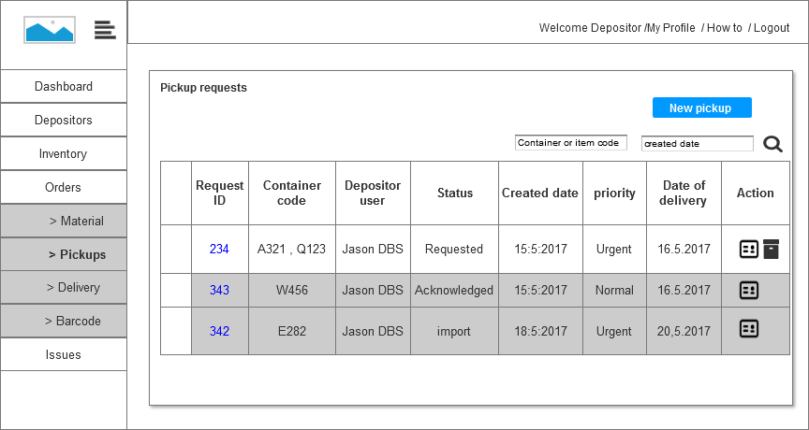

**Screen 10 : pick up request (ORDER) list page**

Order section of the depositor dashboard, shows all the orders he has placed with SK admin. .This page has following use cases or function, Pick up request can be placed for multiple containers.

* It lists all the pickup orders which have been placed with SK admin.
* New pickup request can be place with NEW PICKUP button.
* Each pick request order will be auto allotted a request ID.
* Each row will consists of
* Container codes (if multiple container pickups)
* Who is the depositor user
* Status (“**requested**” when initially order is saved, “**acknowledged**” when the SK personnel as acknowledged the request, and “**import**” when the container is scanned and ready for import )
* Request created date
* Priority , assigned to the request
* Date of delivery, which is calculated by system itself.
* The orders requested cannot be deleted once it has been ACKNOWLEDGED by the SK personnel.
* The orders requested can be deleted in the REQUESTED phase.
* The orders requested can be edited in REQUESTED phase. Once ACKNOWLEDGED, it cannot be edited. See screen 13 and 14.
* The containers details with element can be seen in with expand and collapse icon.
* With  the pick up order detail can be viewed, see screen 11.
* The list can be filtered with container code or item code.

**Create a new pickup request**

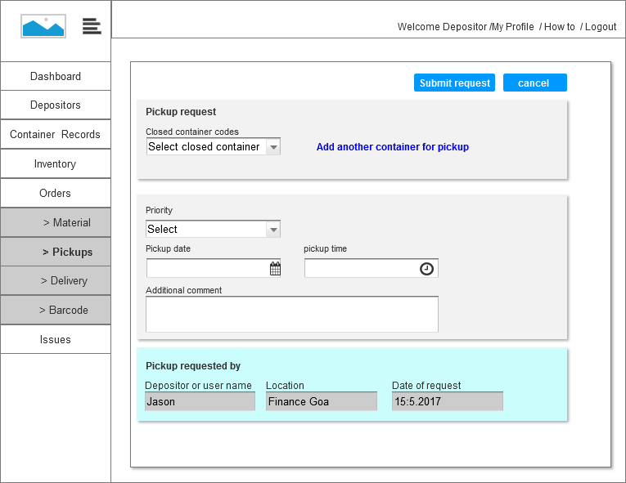

**Screen 11: pick up request detail page.**

* Easy form for creating new pickup request order, it consists of adding containers which has been closed by the depositor user.
* Depositor user can be able to add more containers in the same request for pickup. All the containers in one request will be allotted same request code. Please see screen 12.
* Depositor can select the priority, pick up date and pick up time, and add additional comments to the pickup request.
* The page will automatically show the depositor user details and date of request. (not editable)

**Add another container for pickup**

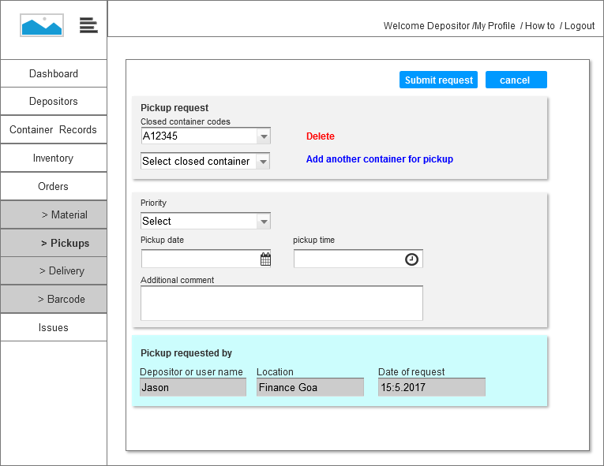

**Screen 12: adding more container to the pick up order**

* The added containers to the pickup request can be deleted or added before the request is acknowledged by SK personnel.

**Update request (till the request has not been acknowledged by SK admin)**

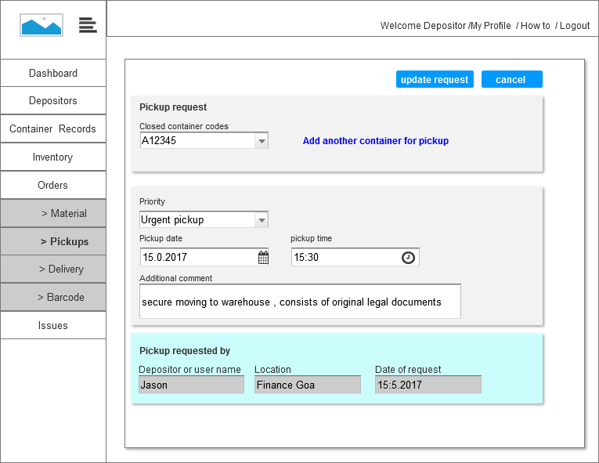

**Screen 13: adding more containers to the pick up order**

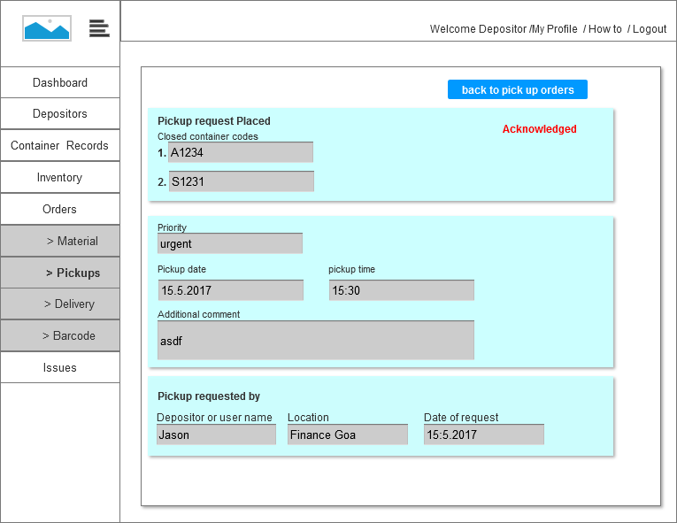

**Screen 14: Pick up acknowledged**